FAREMATRYX: SMART FLIGHT FARE ANALYTICS SYSTEM

Problem Statement: Flight ticket prices change frequently due to demand, season, airline policies, and seat availability, making it difficult for travelers to predict future fares. Many passengers book at the wrong time and pay higher prices. Additionally, comparing fares across multiple platforms is time-consuming, and most booking systems do not provide price forecasts or trend analysis. Therefore, a smart system is needed to predict flight fares, analyze trends, and recommend the best time to book tickets.

Why does this problem exist: The proposed Smart Flight Fare Analytics System uses Machine Learning and Data Analytics to predict flight ticket prices, analyze fare trends, and recommend the best time to book. It helps travelers compare fares, reduce travel costs, and make smarter booking decisions.

Internal Users:
User | Activities
System Administrator | Manage users, maintain the system, monitor performance, update datasets, and control access permissions.
Data Analyst | Analyse flight fare data, generate reports, identify price trends, and evaluate prediction accuracy.
Database Administrator (DBA) | Manage flight datasets, maintain databases, perform backups, and ensure data security.
External Users
User | Activities
Traveller / Passenger | Search flights, view predicted fares, compare prices, analyse trends, and get booking recommendations.
Travel Agent | Compare fares for clients, monitor price changes, and suggest cost-effective booking options.
Airline Staff | View fare analytics, analyse market trends, and monitor competitor pricing.
Travel Companies / Tour Operators | Track flight prices, plan travel packages, and optimise booking schedules.
Researchers / Students | Study fare trends, analyse datasets, and evaluate prediction models for academic purpose.

Objectives of the project:
- Predict future flight ticket prices.
- Analyze historical fare trends.
- Recommend the best time to book.
- Compare fares across airlines and routes.
- Provide visual insights through dashboards and charts.
- Help users save money and make data-driven decisions.
Expected outputs:
- Flight Fare Prediction
- Fare Trend Analysis
- Best Booking Time Recommendation
- Airline and Route Price Comparison
- Visual Dashboards and Reports
- Cost-Saving Recommendations
Strategic information: - Long-term flight fare trends, Seasonal travel demand analysis, Popular routes and travel patterns.
Tactical information: - Best time to book flights, Airline fare comparisons, Route-wise price analysis.
Operational information: - Flight fare prediction, Fare comparison results, User booking recommendations.

Operational Feasibility
- Easy-to-use interface for travellers and travel agents.
- Provides fare prediction and booking recommendations.
- Reduces time spent comparing prices across multiple platforms.
- Helps users make better travel decisions.
- Requires minimal user training.
- Administrators can easily manage data and system operations.
- Supports efficient monitoring and maintenance.

Economic Feasibility
- Uses free and open-source technologies.
- No expensive software licences are required.
- Low development and implementation cost.
- Minimal maintenance expenses.
- Helps users save money by booking flights at the right time.
- Reduces effort and time spent searching for affordable fares.
- Benefits gained are greater than the overall project cost.
Functional Requirements:
- Compare flight fares across airlines
- Predict future ticket prices using ML
- Show fare trends and price analysis
- Suggest cheapest travel dates
- Send fare-drop alerts
- Filter flights by route, date, airline, and budget
- Recommend the best time to book
Non-Functional Requirements:
- Fast search results (< 3 seconds)
- High prediction accuracy (80%+)
- Secure user data
- Mobile-friendly interface
- Real-time fare updates
- Scalable and reliable system
Constraints:
- Budget and time restrictions
- Limited historical data
- Internet required for live updates
Assumptions
- Flight data is accurate
- Users have internet access
- Historical fare data is available
- Fare patterns can be predicted
Ethical Measures
- Data Privacy – Protect user information.
- Transparency – Explain fare predictions clearly.
- Fairness – Avoid bias in recommendations.
- Data Accuracy – Use reliable and updated data.
- Security – Prevent unauthorized access.
- User Consent – Collect data with permission.
- Responsible AI – Ensure unbiased predictions.
- Legal Compliance – Follow data protection laws.

Diagnostic Analysis:
- Analyse reasons for fare increases or decreases.
- Identify the impact of demand on ticket prices.
- Study the effect of holidays and festivals on fares.
- Examine airline pricing strategies.
- Analyse the influence of seat availability on fare changes.
- Compare fare differences between airlines.
- Determine factors causing sudden price fluctuations.

Predictive Analysis:
- Predict future flight ticket prices.
- Forecast fare trends for upcoming days or weeks.
- Estimate price changes based on historical data.
- Predict the best time to book tickets.
- Forecast demand for specific routes.
- Estimate future fare ranges for travellers.
- Generate booking recommendations using machine learning models.

Prescriptive Analysis:
- Recommend the best date to book a flight.
- Suggest the cheapest airline for a selected route.
- Advise users whether to book now or wait.
- Recommend alternative routes with lower fares.
- Suggest cost-saving travel options.
- Provide personalised booking recommendations.
- Alert users when prices are expected to increase.
- Recommend the most economical travel plan based on predictions.

Descriptive Analysis:
- Collect historical flight fare data.
- Display average ticket prices for different routes.
- Show fare trends by airline.
- Analyse seasonal price variations.
- Identify the cheapest and most expensive routes.
- Display booking patterns over time.
- Generate reports and dashboards for fare analysis.

Sustainable Development Goals (SDG)
SDG 9 – Industry, Innovation and Infrastructure
- Uses AI and data analytics to improve flight pricing and travel planning.
SDG 11 – Sustainable Cities and Communities
- Promotes efficient and accessible air travel through better fare insights.
USE CASE DIAGRAM:
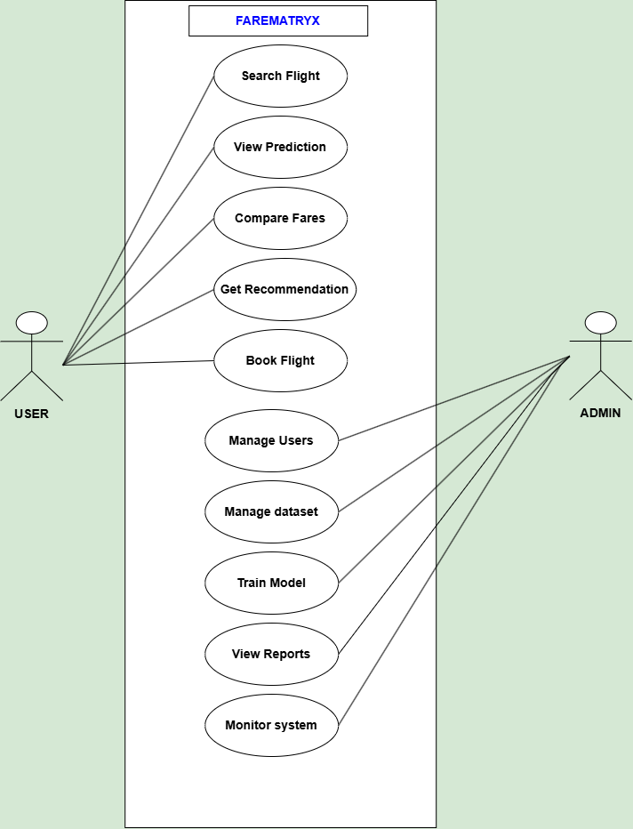

ACTIVITY DIAGRAM:
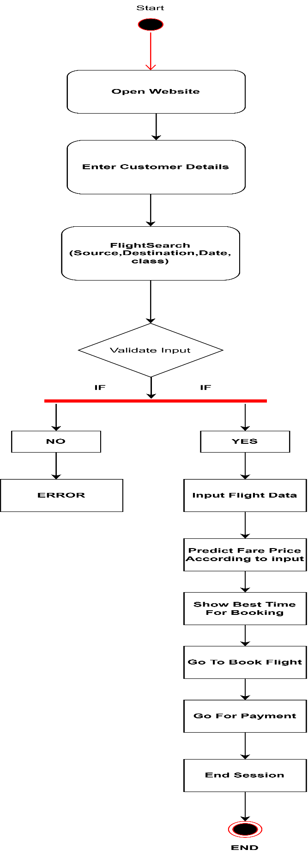

SEQUENCE DIAGRAM:

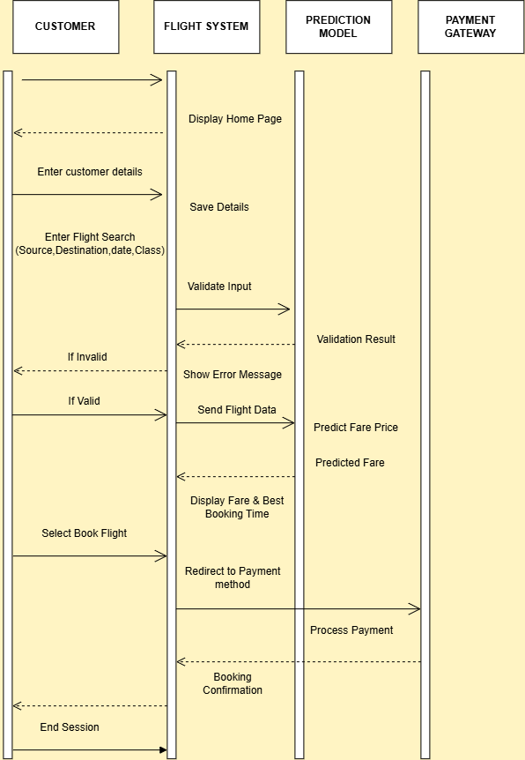

COLLABORATION DIAGRAM:

